**Experiment 12: Huffman coding**

**Aim-** Write a program to perform Huffman Coding on a given set of characters and their frequencies

**Theory:** Huffman coding is a technique used to compress files for transmission

Huffman Coding is a greedy algorithm that constructs an optimal prefix code called the **Huffman Code**.

Example:

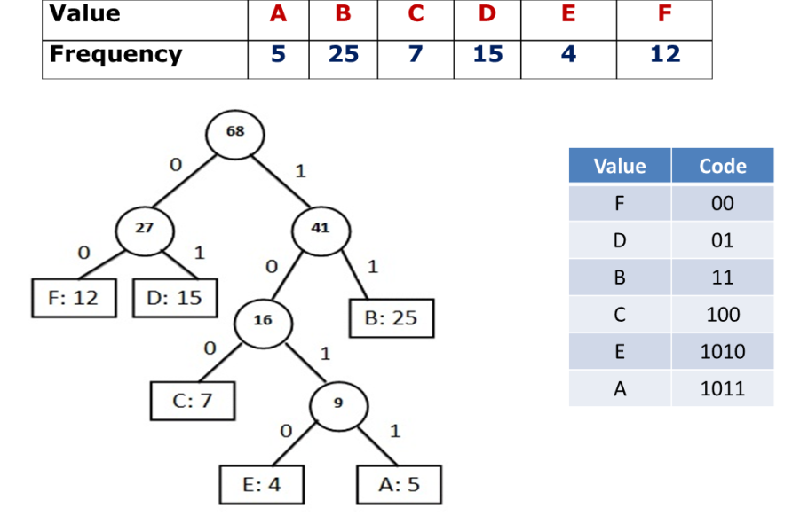

**Algorithm:**

* Step 1: Create a leaf node for each character. Add the character and its weight or frequency of occurrence to the priority queue.
* Step 2: Repeat steps 3 to 5 while the total number of nodes in the queue is greater than 1
* Step 3: Remove two nodes that have the lowest weight (or highest priority)
* Step 4: Create a new internal node by merging these two nodes as children and with weight equal to the sum of the two nodes weights
* Step 5: Add the newly created node to the queue

Program: Huffman coding

#include <stdio.h>

#include <stdlib.h>

#define MAX_TREE_HT 100

struct MinHeapNode {

        char data;

    unsigned freq;

        struct MinHeapNode *left, *right;

};

struct MinHeap {

        unsigned size;

        unsigned capacity;

     struct MinHeapNode** array;

};

struct MinHeapNode* newNode(char data, unsigned freq)

{

    struct MinHeapNode* temp

        = (struct MinHeapNode*)malloc

(sizeof(struct MinHeapNode));

    temp->left = temp->right = NULL;

    temp->data = data;

    temp->freq = freq;

    return temp;

}

struct MinHeap* createMinHeap(unsigned capacity)

 {

     struct MinHeap* minHeap

        = (struct MinHeap*)malloc(sizeof(struct MinHeap));

    minHeap->size = 0;

     minHeap->capacity = capacity;

     minHeap->array

        = (struct MinHeapNode**)malloc(minHeap->

capacity * sizeof(struct MinHeapNode*));

    return minHeap;

}

void swapMinHeapNode(struct MinHeapNode** a,

                     struct MinHeapNode** b)

{

     struct MinHeapNode* t = *a;

    *a = *b;

    *b = t;

}

void minHeapify(struct MinHeap* minHeap, int idx)

{

    int smallest = idx;

    int left = 2 * idx + 1;

    int right = 2 * idx + 2;

    if (left < minHeap->size && minHeap->array[left]->

freq < minHeap->array[smallest]->freq)

        smallest = left;

    if (right < minHeap->size && minHeap->array[right]->

freq < minHeap->array[smallest]->freq)

        smallest = right;

    if (smallest != idx) {

        swapMinHeapNode(&minHeap->array[smallest],

                        &minHeap->array[idx]);

        minHeapify(minHeap, smallest);

    }

}

int isSizeOne(struct MinHeap* minHeap)

{

     return (minHeap->size == 1);

}

struct MinHeapNode* extractMin(struct MinHeap* minHeap)

 {

    struct MinHeapNode* temp = minHeap->array[0];

    minHeap->array[0]

        = minHeap->array[minHeap->size - 1];

    --minHeap->size;

    minHeapify(minHeap, 0);

    return temp;

}

void insertMinHeap(struct MinHeap* minHeap,

                   struct MinHeapNode* minHeapNode)

{

    ++minHeap->size;

    int i = minHeap->size - 1;

    while (i && minHeapNode->freq < minHeap->array[(i - 1) / 2]->freq) {

         minHeap->array[i] = minHeap->array[(i - 1) / 2];

        i = (i - 1) / 2;

    }

    minHeap->array[i] = minHeapNode;

}

void buildMinHeap(struct MinHeap* minHeap)

 {  int n = minHeap->size - 1;

    int i;

    for (i = (n - 1) / 2; i >= 0; --i)

        minHeapify(minHeap, i);

}

void printArr(int arr[], int n)

{

    int i;

    for (i = 0; i < n; ++i)

        printf("%d", arr[i]);

    printf("\n");

}

int isLeaf(struct MinHeapNode* root)

{     return !(root->left) && !(root->right);

}

struct MinHeap* createAndBuildMinHeap(char data[], int freq[], int size)

 {    struct MinHeap* minHeap = createMinHeap(size);

      for (int i = 0; i < size; ++i)

        minHeap->array[i] = newNode(data[i], freq[i]);

    minHeap->size = size;

    buildMinHeap(minHeap);

    return minHeap;

}

struct MinHeapNode* buildHuffmanTree(char data[], int freq[], int size)

 {  struct MinHeapNode *left, *right, *top;

    struct MinHeap* minHeap = createAndBuildMinHeap(data, freq, size);

    while (!isSizeOne(minHeap)) {

        left = extractMin(minHeap);

        right = extractMin(minHeap);

        top = newNode('$', left->freq + right->freq);

        top->left = left;

        top->right = right;

       insertMinHeap(minHeap, top);

    }

   return extractMin(minHeap);

}

void printCodes(struct MinHeapNode* root, int arr[], int top)

 {  if (root->left) {

      arr[top] = 0;

        printCodes(root->left, arr, top + 1);

    }

        if (root->right) {

        arr[top] = 1;

        printCodes(root->right, arr, top + 1);

    }

    if (isLeaf(root)) {

          printf("%c: ", root->data);

        printArr(arr, top);

    }

}

void HuffmanCodes(char data[], int freq[], int size)

{         struct MinHeapNode* root

        = buildHuffmanTree(data, freq, size);

      int arr[MAX_TREE_HT], top = 0;

      printCodes(root, arr, top);

}

  int main()

{

    char arr[] = { 'a', 'b', 'c', 'd', 'e', 'f' };

    int freq[] = { 5, 9, 12, 13, 16, 45 };

    int size = sizeof(arr) / sizeof(arr[0]);

    HuffmanCodes(arr, freq, size);

    return 0;

}